Figurative Language Think Sheet

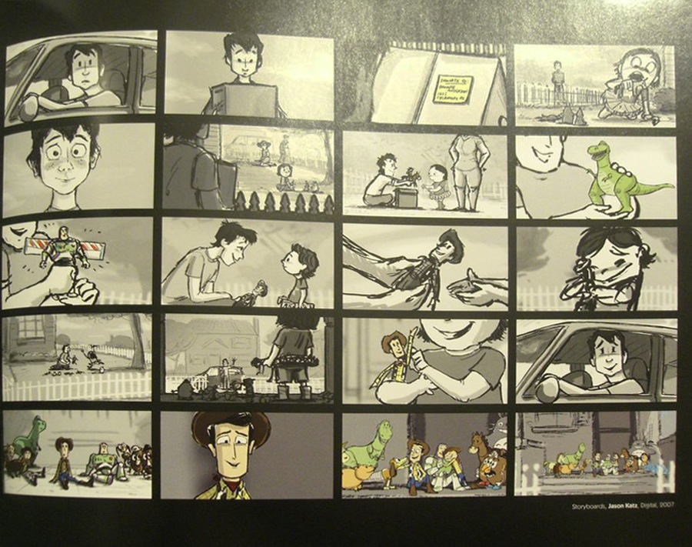
Use this think sheet to prepare for your project!
Information:
Storyboards are created by moviemakers, comic book makers, and even authors, to help brainstorm their ideas before they start to produce. Here is an example from Toy Story 3:

Creating Figurative Language:
- Simile : ___________________________________________ ___________________________________________
- Metaphor: ___________________________________________ ___________________________________________
- Alliteration: _________________________________________________________________________
- Idiom: _________________________________________________________________________
- Personification: _________________________________________________________________________
- Onomatopoeia: _________________________________________________________________________
- Hyperbole: _________________________________________________________________________
- Oxymoron: _________________________________________________________________________
- Pun:
_________________________________________________________________________

Sketching your Storyboard: Use your examples to create a picture in each of the storyboard squares. Push your limits and see if you can create a story that flow!
Simile | Metaphor | Alliteration | Idiom
Personification | Hyperbole | Onomatopoeia  Pun | Oxymoron

Go to www.storyboardthat.com and start creating your storyboard! Have fun and work together!
Presentation Notes:
How is your group going to present the information? Who is going to present each storyboard tile? What are you going to say about each tile?
Tile 1 Presenter: _______________________ Notes: ________________________________
Tile 2 Presenter: _______________________ Notes: ________________________________ Tile 3 Presenter: _______________________ Notes: ________________________________ Tile 4 Presenter: _______________________ Notes: ________________________________ Tile 5 Presenter: _______________________ Notes: ________________________________ Tile 6 Presenter: _______________________ Notes: ________________________________ Tile 7 Presenter: _______________________ Notes: ________________________________ Tile 8 Presenter: _______________________ Notes: ________________________________
Tile 9 Presenter: _______________________ Notes: ________________________________

